**PUDUCHERRY TECHNOLOGICAL UNIVERSITY**

DEPARTMENT OF INFORMATION TECHNOLOGY

**IT224-WEB TECHNOLOGY LABORATORY**



**MINI PROJECT**

ONLINE FLIGHT TICKET BOOKING AND MANAGEMENT SYSTEM

Done by   
Abhinav S – 21IT1001

Anish T K – 21IT1004

Chozha Valavan S – 21IT1011

SUBMITTED TO

DR. P. MARAGATHAVALLI

PROFESSOR

CONTENT TABLE

|  |  |  |
| --- | --- | --- |
| **Sl.No.** | **Topic** | **Page No.** |
| 1 | ABSTRACT | 3 |
| 2 | INTRODUCTION | 3 |
| 3 | LITERATURE SURVEY | 3 |
| 4 | FEATURES | 4 |
| 5 | UI SNAPSHOTS | 4 |
| 6 | CONCLUSION | 18 |

**ABSTRACT**

The project aims to design and implement an air ticket reservation system that provides customers with a facility to reserve their tickets without any hassle. This web-based system saves valuable time and effort for air travellers. The system was developed using PHP, JavaScript, CSS, and HTML as programming languages and Oracle SQL developer as the database management system tool. The Agile methodology was adopted for this project. The system allows real-time communication between the admin and user, enabling passengers to cancel their reservations, view price charts, and search for flights between two travel cities.

**INTRODUCTION**

The online flight ticket booking system is designed to make air ticket reservation easier for passengers, saving time and effort for potential air travellers, and reducing the hassle of the user. The system allows passengers to search for flights, book tickets, and cancel reservations online.

**LITERATURE SURVEY**

Survey The existing system of air ticket reservation has several limitations, including manual intervention, lack of web services and remoting, risk of mismanagement and data loss, less security, and no proper coordination between different applications and users. The proposed system ensures complete freedom for users, where users can log on to the website and book their tickets online.

**FEATURES**

The system has the following features:

* Search for flights between two travel cities
* Book tickets online and Check-in to the terminal via online.
* Cancel reservations online
* View flight details, price charts, flight status, bookings.
* Real-time communication between admin and user
* User-friendly interface
* High-level security with different levels of authentication

**UI SNAPSHOTS**

SAMPLE INPUTS AND OUTPUTS:

USER SIDE:

HOME PAGE : HOME.PHP

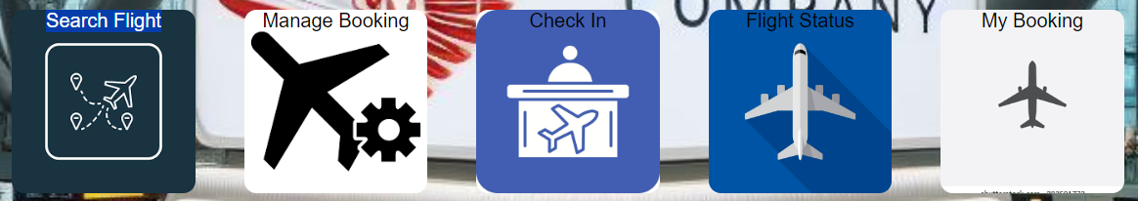

LOGIN:

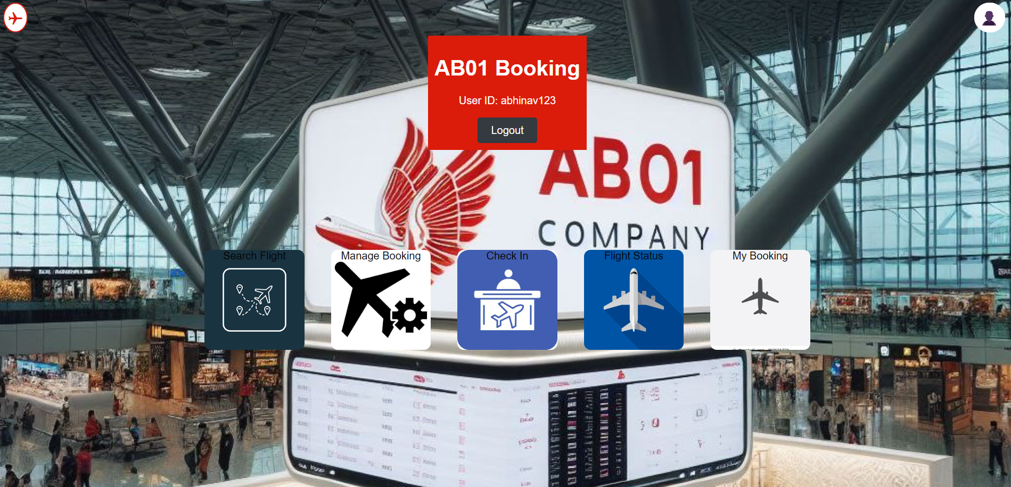



SIGNUP PAGE: SIGNUP.PHP

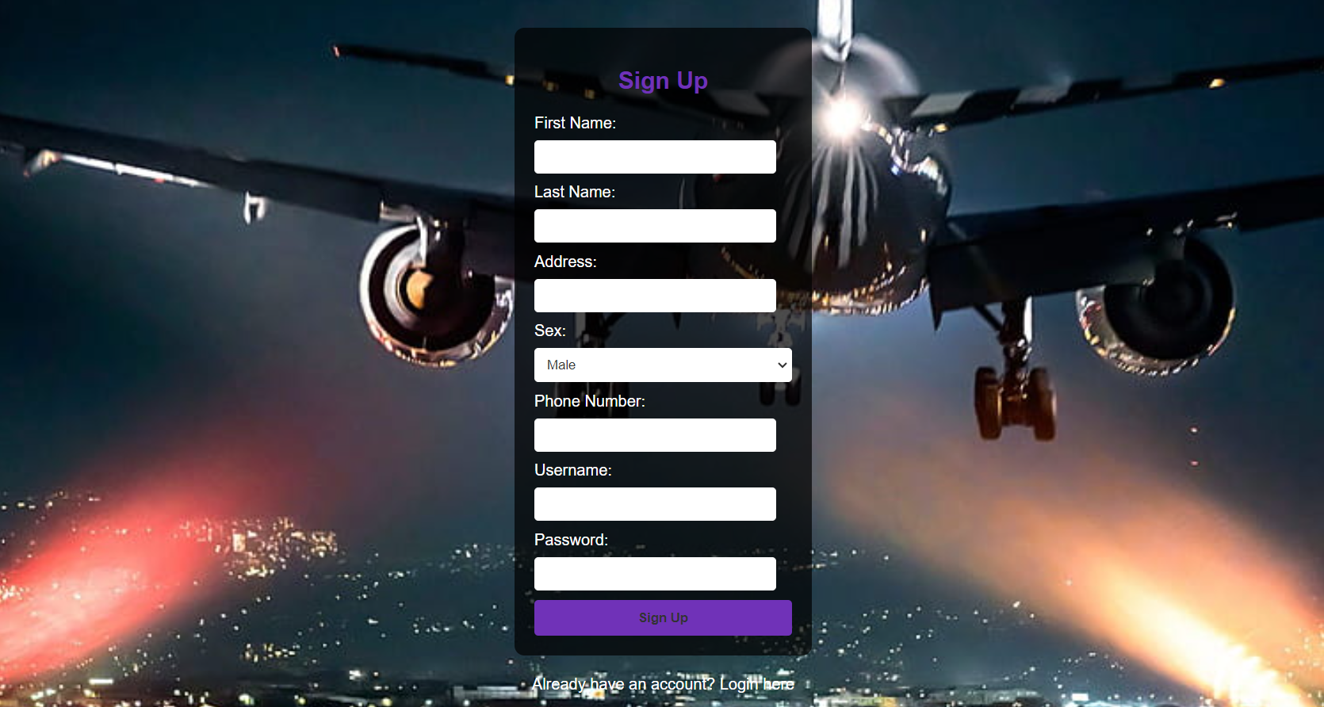

LOGIN PAGE: LOGIN.PHP

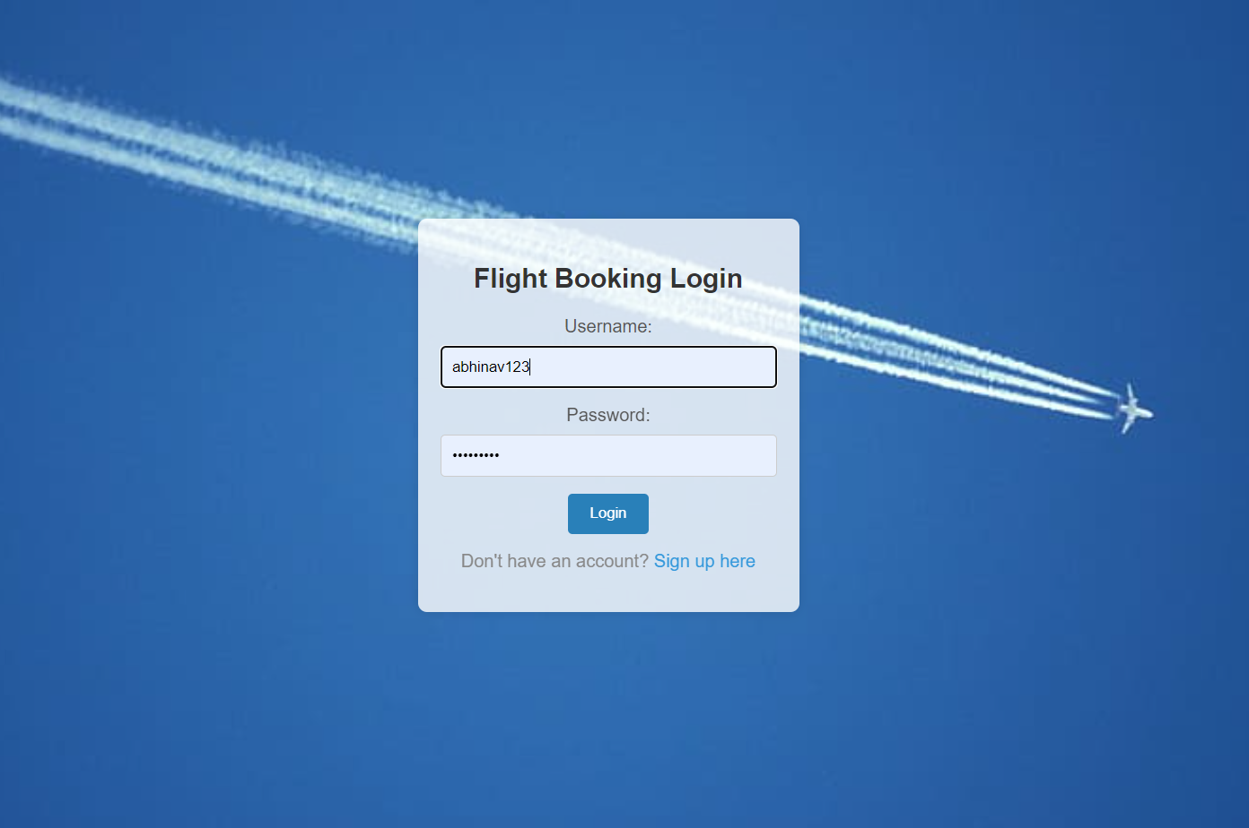

USER DETAILS PAGE : USERDETAILS.PHP

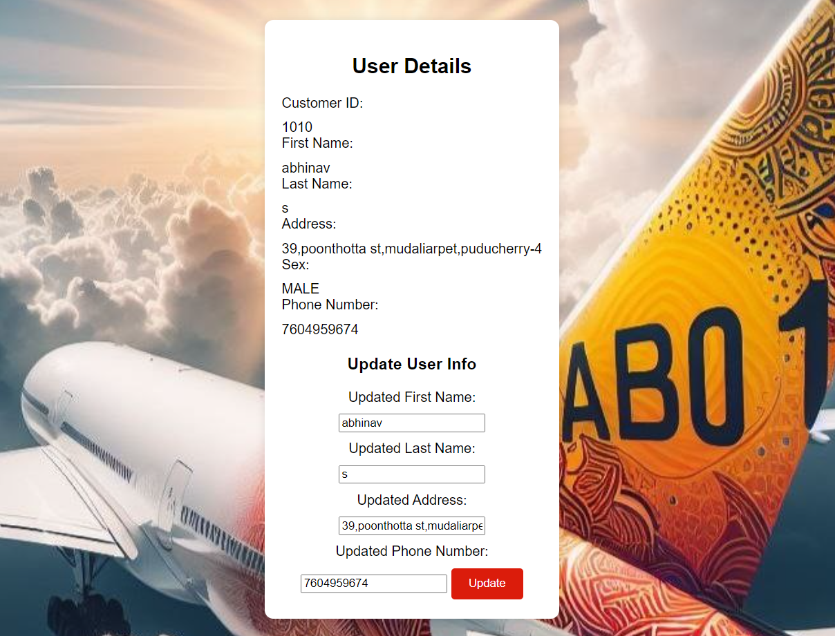

MY BOOKINGS PAGE : MYBOOKINGS.PHP

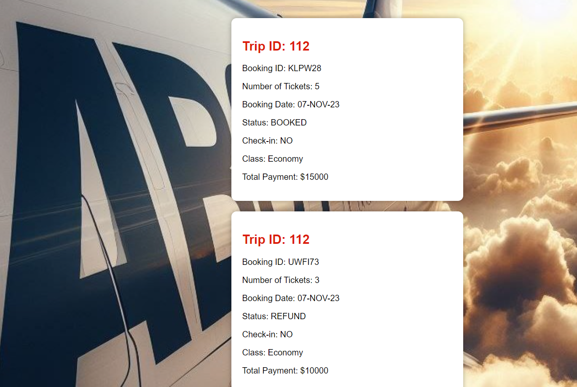

CHECK FLIGHT STATUS PAGE : FLIGHTSTATUS.PHP

INPUT:

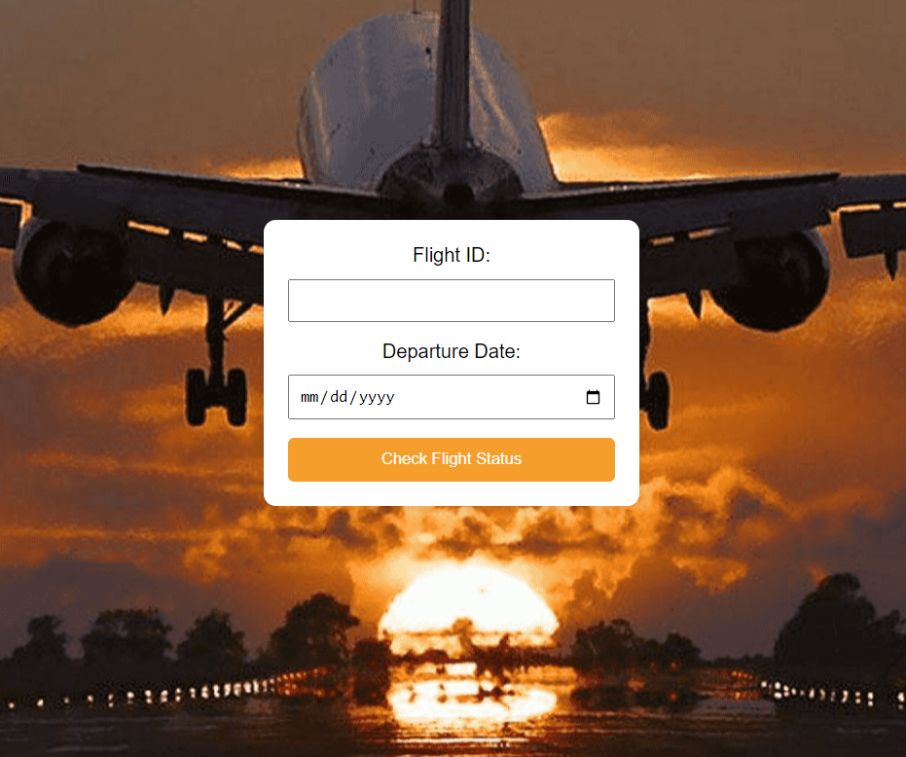

OUTPUT:

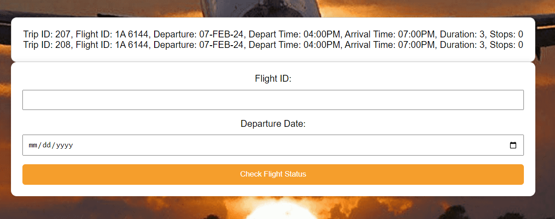

CHECK IN PAGE : CHECKIN.PHP

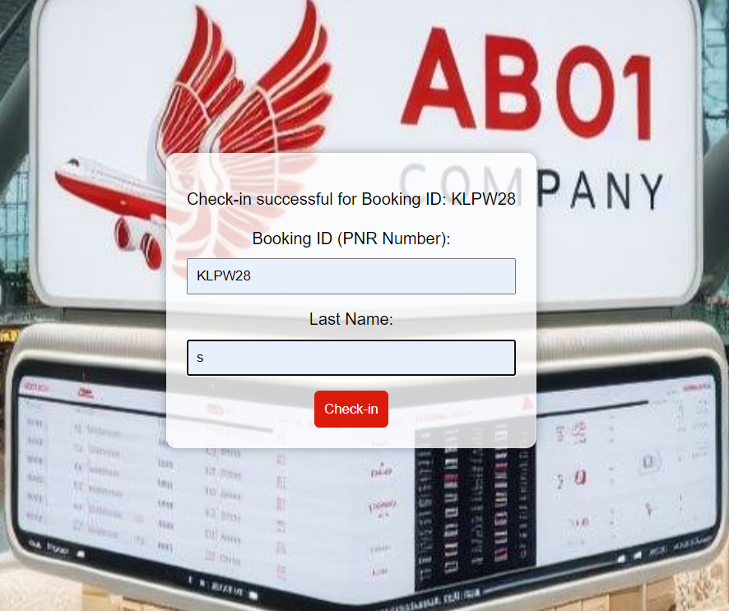

MANAGE BOOKING PAGE : MANAGEBOOKING.PHP

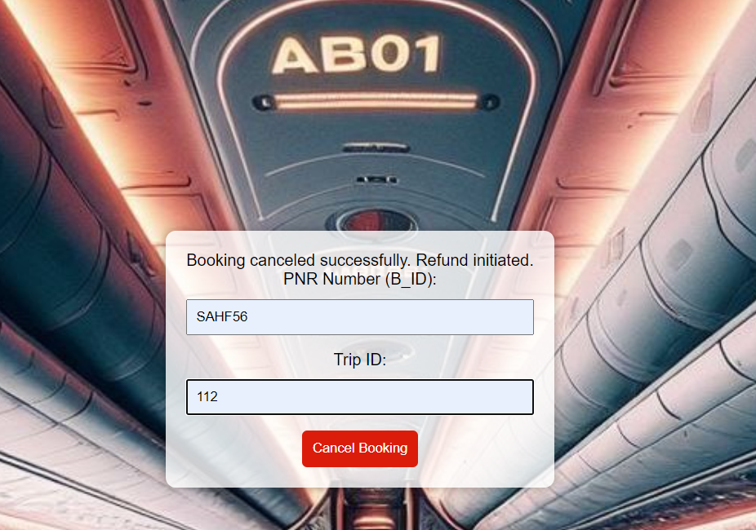

SEARCH FLIGHTS PAGE : SEARCHFLIGHT.PHP ---> BOOKING.PHP

INPUT:

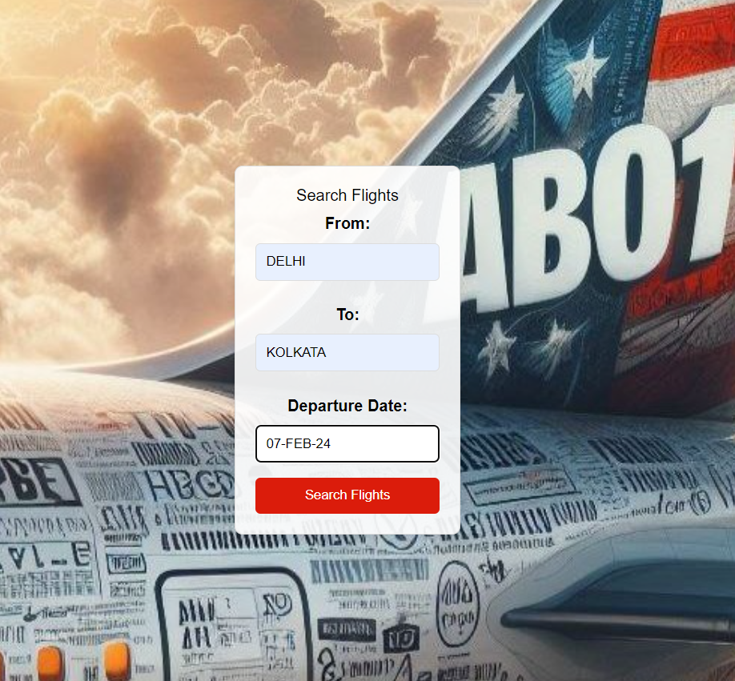

OUTPUT:

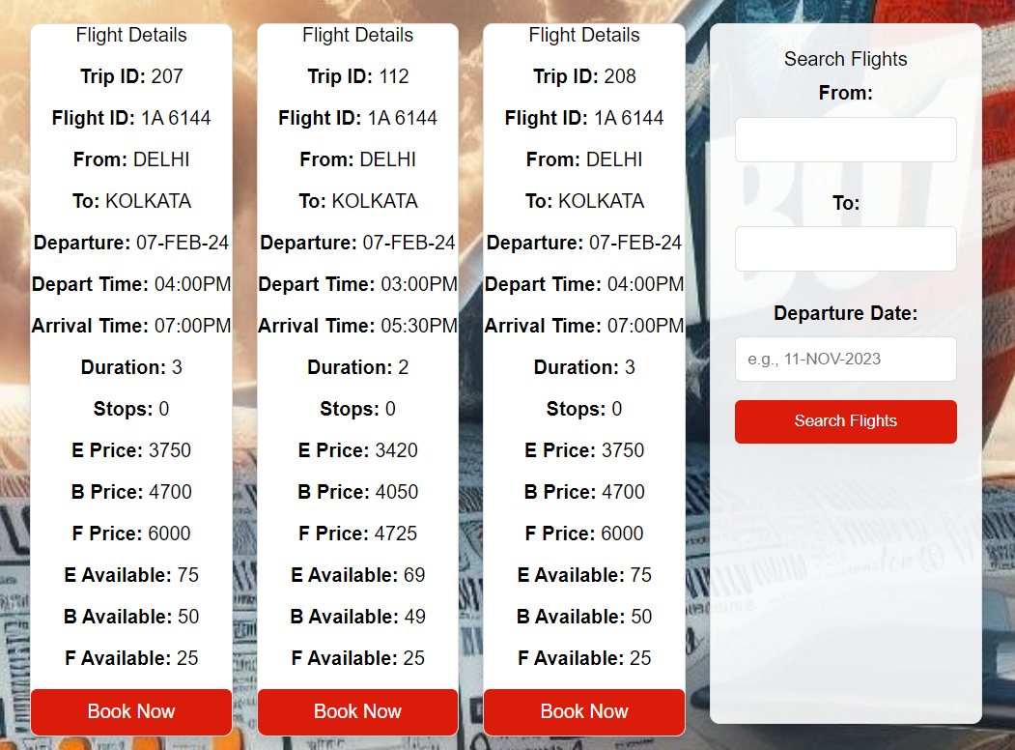

BOOKING PAGE : BOOKING.PHP

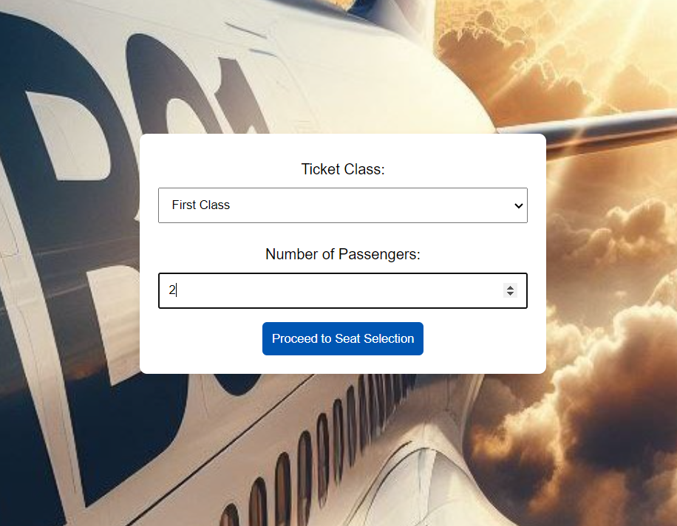

SEAT SELECTION PAGE: SEATGEN.PHP

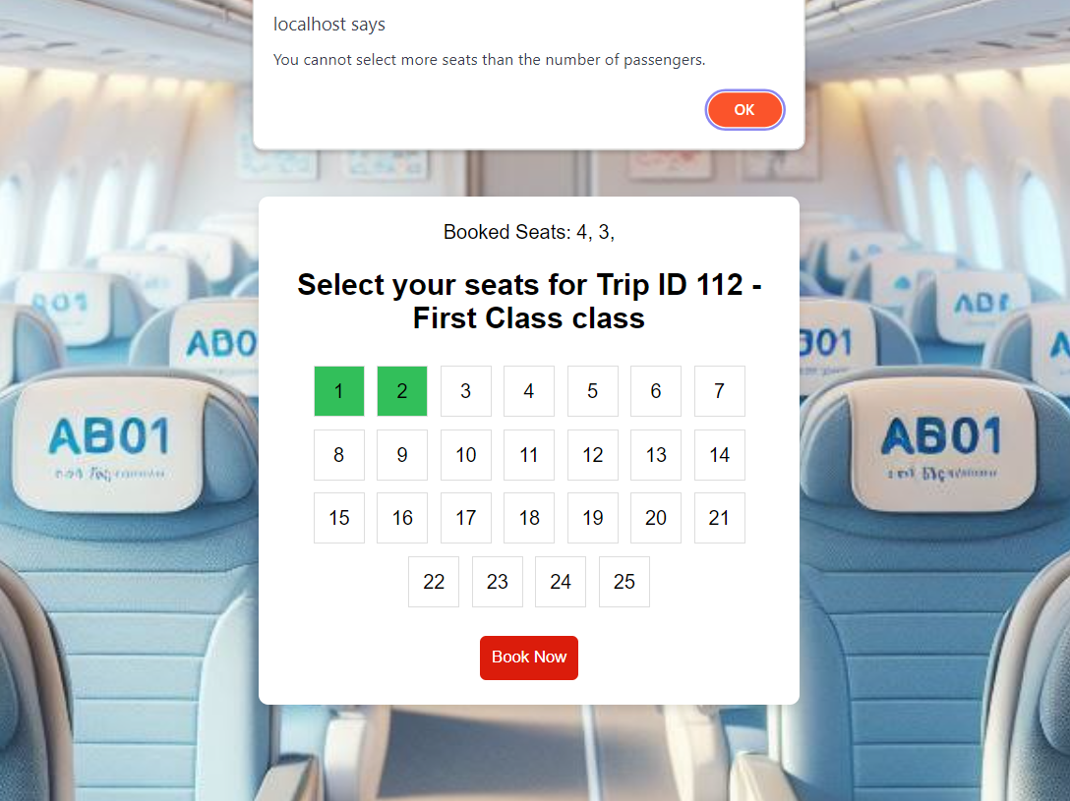

FINALBOOKING.PHP



ADMIN SIDE:

HOME PAGE : ADMIN_HOME.PHP

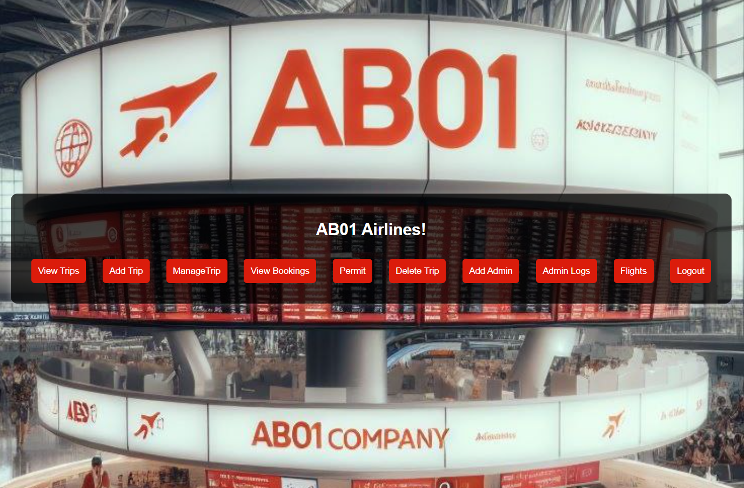

LOGIN PAGE : ADMINLOGIN.PHP

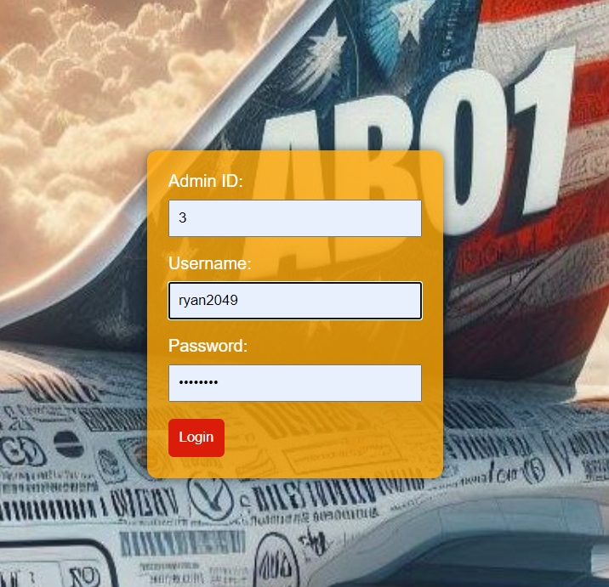

VIEW TRIPS PAGE : VIEWTRIP.PHP

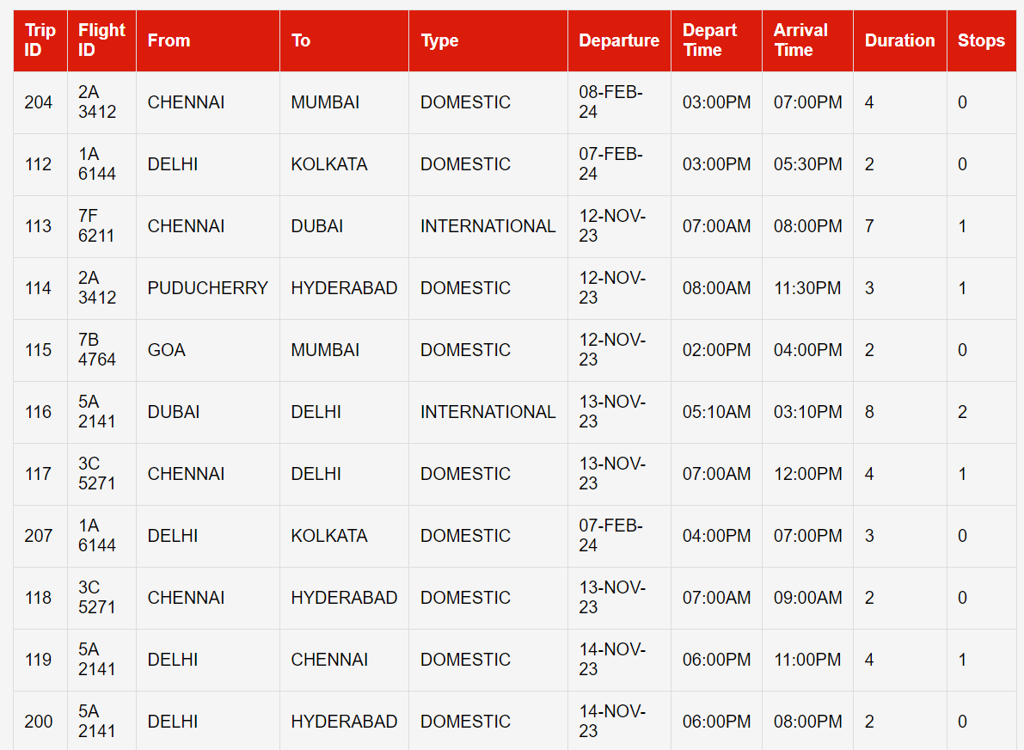

ADD TRIP PAGE : ADDTRIP.PHP

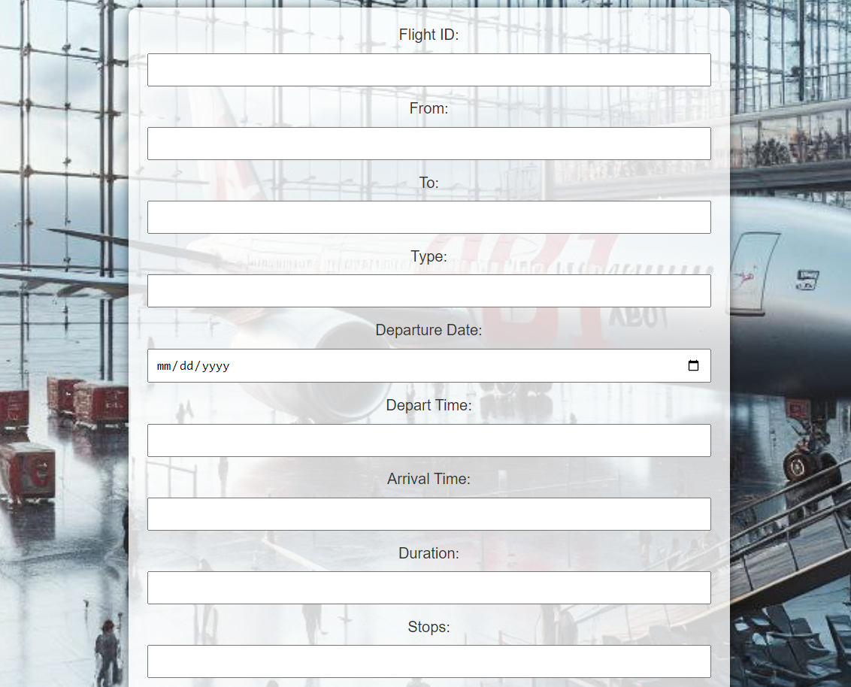

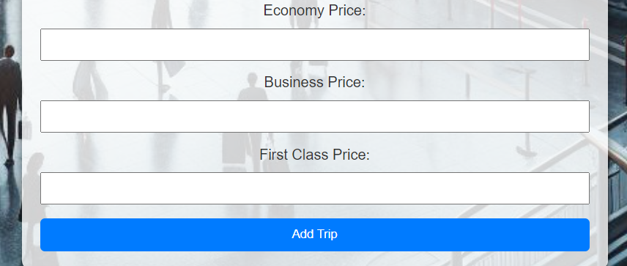

MANAGE TRIP PAGE (DELAY) :

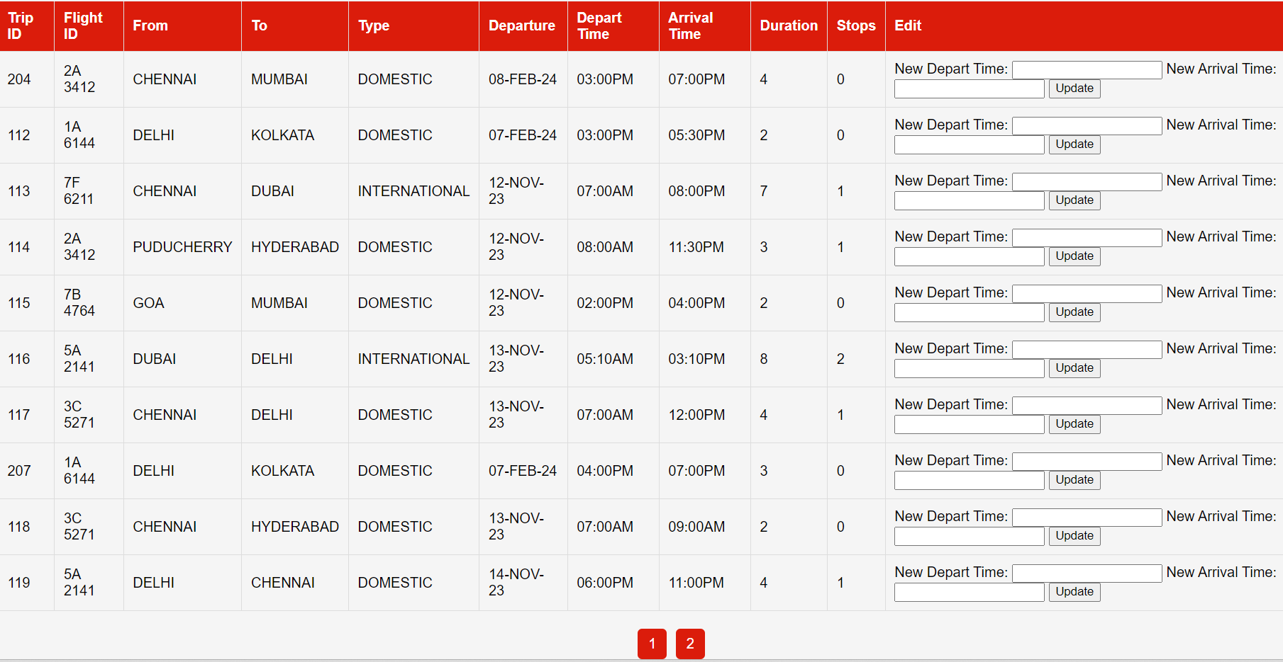

VIEW BOOKINGS PAGE :

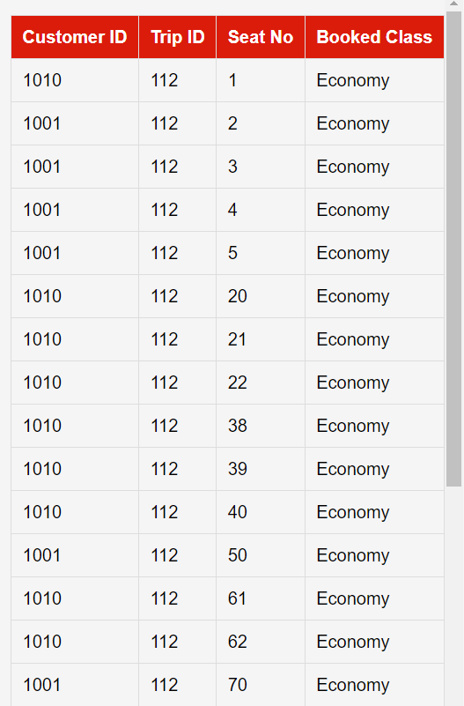

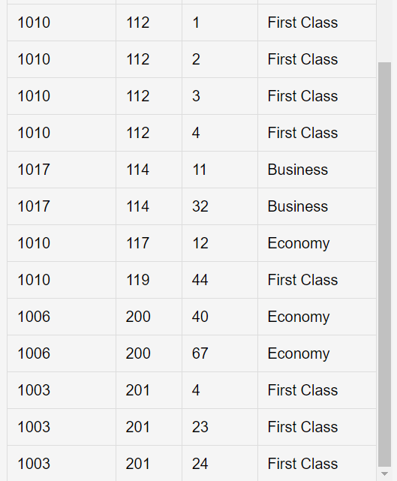

DELETE TRIP PAGE:



ADD ADMIN PAGE:

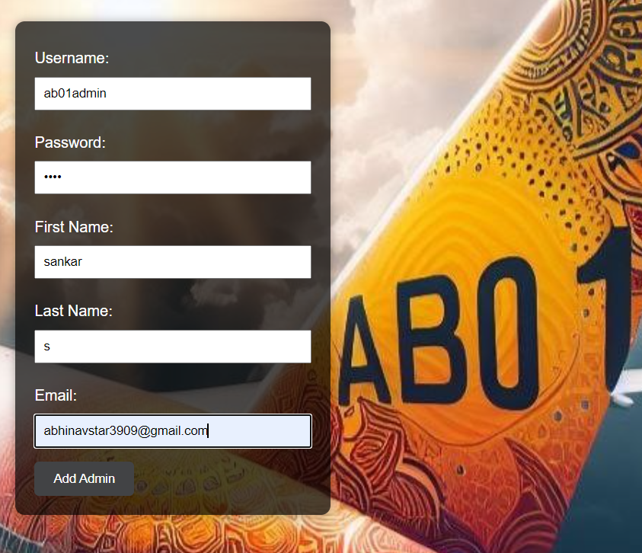

ADMIN LOGS PAGE:

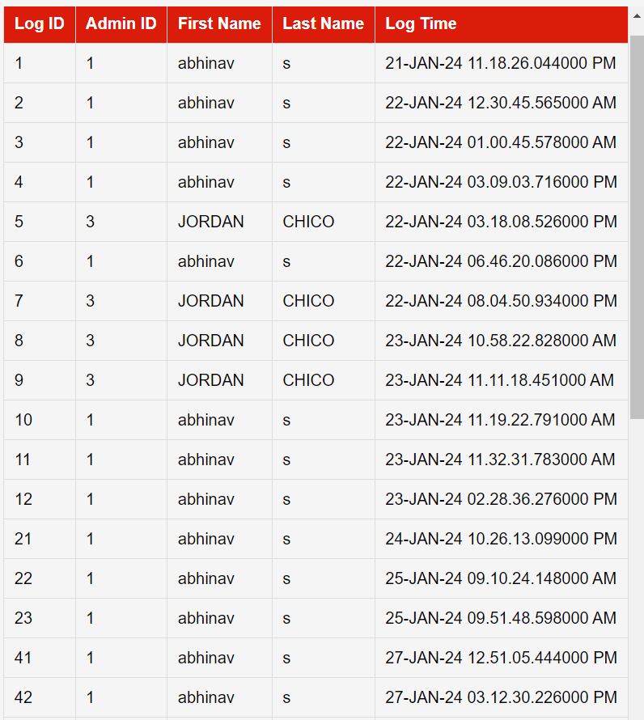

PERMIT PAGE : PERMIT.PHP

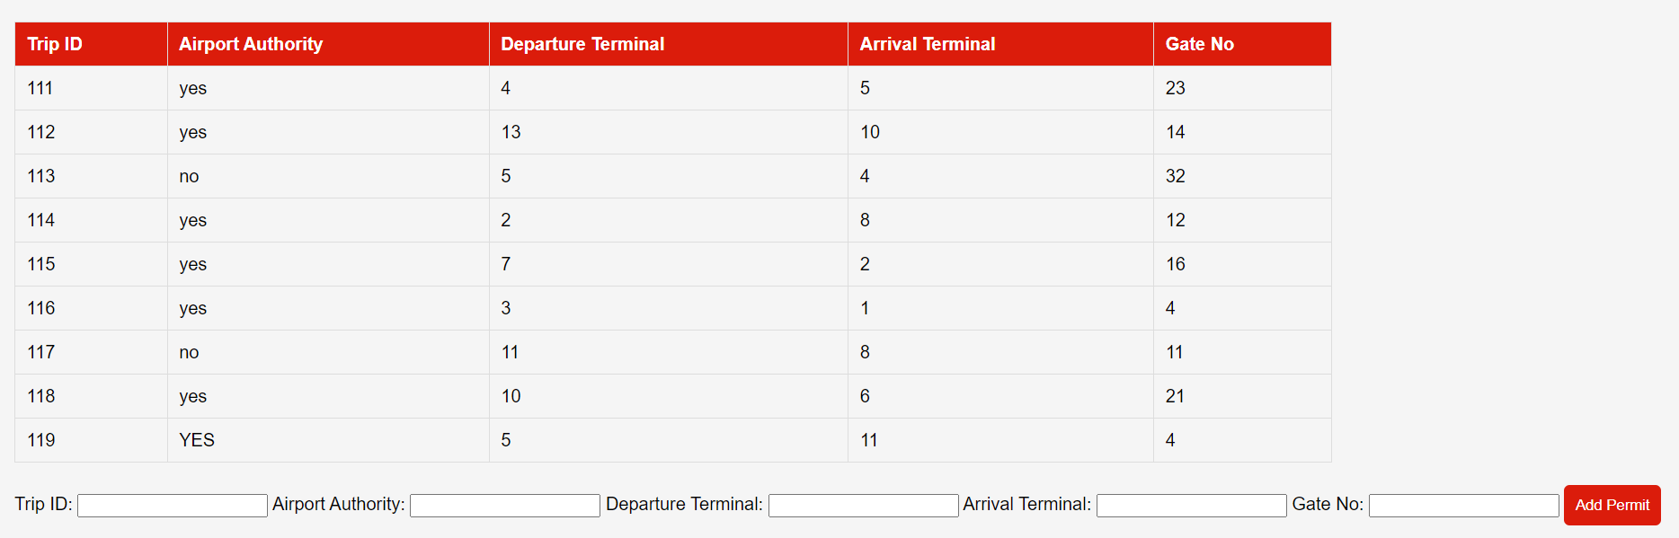

ADD FLIGHTS PAGE : ADDFLIGHT.PHP

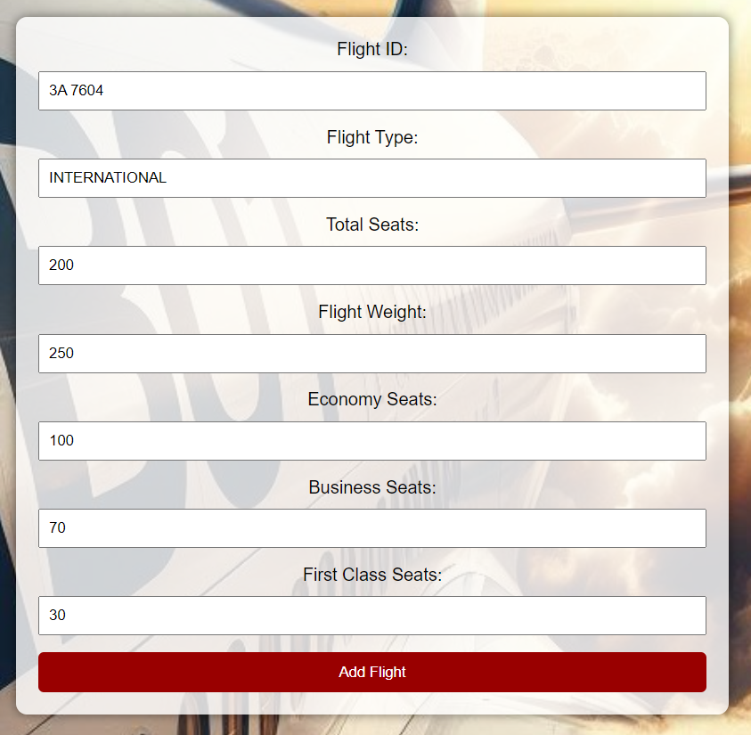

**CONCLUSION**

The online flight ticket booking system is a web-based system that provides customers with a facility to reserve their tickets online, saving time and effort for air travellers. The system has several features, including search for flights, book tickets, cancel reservations, and view price charts. The system ensures high-level security and is user-friendly.

**VIEW SOURCE CODE**

**GitHub -** [**https://github.com/JOHNWICKabi/Airlines**](https://github.com/JOHNWICKabi/Airlines)